

REAL-TIME INTENT-AWARE E-COMMERCE PERSONALIZATION USING AI

A PROJECT REPORT
Submitted by
Subash Chandra Bose G (211222205018)
Sowmiya K (211222205017)
Sandhiya M (211222205014)

In partial fulfillment for the award of the degree
BACHELOR OF TECHNOLOGY
IN
INFORMATION TECHNOLOGY
ST LOURDES ENGINEERING COLLEGE
ANNA UNIVERSITY: CHENNAI 600 025
MAY 2026

BONAFIDE CERTIFICATE

Certified that this project report titled “REAL-TIME INTENT-AWARE E-COMMERCE PERSONALIZATION USING AI” is the Bonafide work of SUBASH CHANDRA BOSE G (211222205018), SOWMIYA K (211222205017) and SANDHIYA.M (211222205013)
WHO CARRIED OUT THE PROJECT WORK UNDER SUPERVISION

SIGNATURE SIGNATURE
Mrs. Sharmila M.E., Mr.J.Sivamurugan M.E.,(Ph.D).,, HEAD OF THE DEPARTMENT SUPERVISOR Department of Information Technology Department of CSE St.Lourdes Engineering College St.Lourdes Engineering College Chennai-600128 Chennai-600128

ACKNOWLEDGMENT

With deep reverence and gratitude, I begin by thanking the Almighty for His abundant grace, strength, and guidance throughout the successful completion of this I am final year project. immensely grateful to Dr. Ln. S. Peter, Founder and Chairman of our esteemed institution, for his visionary leadership and for fostering an environment of academic excellence and innovation.
I extend my sincere thanks to Ms. Mercy Florence Peter, Vice Chairperson, for her continuous encouragement, support, and commitment to student development.
My heartfelt appreciation goes to Mr. Ajay Ravindra Kumar, Managing Director, for his dedicated efforts in ensuring the institution’s progress and for providing the resources necessary to pursue this academic endeavour.
I am truly thankful to our respected Dr. Suresh Mohan Kumar. P, B.E., M.E., Ph.D., Head of the Institution for his unwavering support and guidance, which served as a great source of motivation throughout this project.
I also wish to express my deepest gratitude to Mrs.Sharmila M.E., Head of the of Information Technology, for her invaluable insights, encouragement, and for facilitating the smooth execution of this project within the department.
A special note of thanks to my project supervisor, Mr.J.Sivamurugan M.E.,(Ph.D)., whose expert guidance, technical acumen, and consistent support played a crucial role in shaping this project to its successful conclusion.
I am also thankful to all the faculty members and technical staff of the Cluster of Computer Science and Engineering for their cooperation and academic support at various stages of this work.
Finally, I am deeply indebted to my family, peers, and friends for their constant encouragement, moral support, and belief in my efforts during this journey.

CHAPTER NO TABLE OF CONTENTS PAGE NO

ABSTRACT

1. INTRODUCTION
1.1 Overview of E-Commerce Systems
1.2 Growth of Online Shopping Platforms
1.3 Artificial Intelligence in E-Commerce
1.4 Personalization in Online Shopping Platforms
1.5 User Behavior Analysis in E-Commerce Systems
1.6 Problem Statement
1.7 Objectives of the Proposed System
1.8 Scope of the Project
1.9 Organization of the Thesis

2. LITERATURE SURVEY
2.1 Recommendation Systems in E-Commerce
2.2 Collaborative Filtering Based Recommendation System
2.3 Content Based Recommendation System
2.4 Hybrid Recommendation Techniques
2.5 Real-Time User Behavior Tracking Systems
2.6 Artificial Intelligence Based Personalization
2.7 Machine Learning Techniques for Recommendation Systems
2.8 Intent Detection in Online Shopping Platforms
2.9 Data Driven Personalization Techniques
2.10 Intelligent E-Commerce Platforms using AI

3. SYSTEM ANALYSIS
3.1 Overview of Recommendation Systems
3.2 Analysis of Existing E-Commerce Recommendation Systems
3.3 Limitations of Existing Systems
3.4 Need for Real-Time Intent-Aware Personalization
3.5 Proposed System Overview
3.6 Advantages of the Proposed System
3.7 System Architecture
3.7.1 System Architecture diagram
3.7.2 User Behavior Tracking Flowchart
3.8 System Requirements Analysis
3.9 Functional Requirements
3.10 Non-Functional Requirements

4. LANGUAGE SPECIFICATION
4.1 Overview of Programming Languages and Technologies Used
4.2 Python Programming Language for Machine Learning Implementation
4.3 Intent Detection using Machine Learning
4.4 Web Development Technologies (HTML, CSS, JavaScript)
4.5 Frontend Framework for User Interface Development
4.6 Backend Development for Recommendation System
4.7 Database Management System for Data Storage
4.8 Development Tools and Software Requirements
4.9 Integration of AI with E-Commerce Platform
4.10 System Workflow

5. CONCLUSION & REFERENCES
5.1 Conclusion
5.2 References

6. APPENDIX
6.1 Coding
6.2 Code for User Interface (Frontend)
6.2.1 Code for Product Page
6.2.2 Code for Product Card
6.2.3 Code for Recommendation Section
6.2.4 Code for Compare Products
6.2.5 Coding for Rating Stars
6.2.6 Coding for Recently Viewed Products
6.3 Code for Recommendation System Module
6.3.1 Code for Recommendation Engine
6.3.2 Code for Similar Products
6.3.3Code for Popularity Score
6.3.4 Code for Intent Recommendation
6.4 Code for User Behavior Tracking Module
6.4.1 Code for Behavior Tracker
6.4.2 Code for User Interaction Logger
6.4.3 Code for Session Tracking
6.5 Code for Machine Learning Model
6.5.1 Code for Intent Model
6.5.2 Code for Train Intent Model
6.5.3 Code for Predict Intent
6.6 Code for Backend / API files
6.6.1 Code for Product controller
6.6.2 Code for Recommendation controller
6.6.3 Code for Product service
6.7 Sample Dataset Used
6.7.1 Sample Product Dataset
6.7.2 Sample User Behavior Dataset
6.7.3 Sample Recommendation Output
6.8 Implementation

LIST OF FIGURES
3.7 System Architecture
3.7.1 System Architecture Diagram
3.7.2 User Behavior Tracking Flowchart
4.10 System Workflow
6.8.1 E-Commerce Platform Home Page Interface
6.8.2 User Registration Interface
6.8.3 User Login Authentication Interface
6.8.4 Product Search Interface
6.8.5 Trending and Newly Launched Products Interface
6.8.6 Related Products Recommendation Interface
6.8.7 Smart Product Face-Off Comparison Interface
6.8.8 Payment Successful Confirmation Page
6.8.9 Admin Dashboard Overview Interface
6.8.10 Product Inventory Management Interface
6.8.11 Warehouse Stock Management Interface
6.8.12 Admin Panel – User Management Interface
6.8.13 Secure Payment and Checkout Interface

LIST OF ABBREVIATION
1.3 AI-Artificial Intelligence
3.7.1 UI-User Interface
4.1 HTML-Hypertext Markup Language
4.4 CSS-Cascading Style Sheet
4.6 API-Application Programming Interface
4.7 DBMS-Database Management System
4.8 IDE-Integrated Development Environment

LIST OF TABLES

6.7.1 Sample Product Dataset
6.7.2 Sample User Behavior Dataset
6.7.3 Sample Recommendation Output

7. CERTIFICATE

ABSTRACT

The rapid growth of e-commerce platforms has transformed the way people shop and interact with online marketplaces. With thousands of products available on digital platforms, users often find it difficult to identify items that match their interests and preferences efficiently. Traditional recommendation systems used in many e-commerce websites mainly rely on static approaches such as collaborative filtering, popularity-based suggestions, and historical purchase data. Although these methods provide basic recommendations, they fail to understand the real-time intent of users during their browsing sessions. As a result, users may receive irrelevant product suggestions, which reduces engagement and negatively affects the overall shopping experience.
The proposed system, Real-Time Intent-Aware E-Commerce Personalization using Artificial Intelligence, aims to improve the effectiveness of recommendation systems by dynamically identifying user intent and providing personalized product suggestions. The system continuously monitors user activities such as search queries, product clicks, browsing history, time spent on specific product pages, and cart interactions. These behavioral patterns are analyzed using artificial intelligence and machine learning techniques to determine the user's current intent, which may include browsing products, comparing multiple items, or preparing to make a purchase.
Based on the detected intent, the system generates personalized recommendations, customized offers, and adaptive product displays in real time. This approach enables the platform to provide more relevant product suggestions and improves the efficiency of product discovery. The use of machine learning models allows the system to adapt to changing user behavior and provide intelligent recommendations within the same browsing session.
The proposed solution not only enhances user satisfaction but also benefits e-commerce businesses by increasing customer engagement, improving conversion rates, and optimizing marketing strategies. Furthermore, the system is designed to be scalable and capable of handling large volumes of user data, making it suitable for integration into modern e-commerce platforms.
Overall, the implementation of real-time intent-aware personalization demonstrates how artificial intelligence can significantly enhance the performance and effectiveness of recommendation systems in online shopping environments, creating a more interactive and user-centric digital marketplace.

CHAPTER
INTRODUCTION

The Introduction section of the project provides a basic understanding of the problem and the purpose of the system being developed. It explains the background of the project and why the proposed system is needed. In this project, the introduction focuses on the importance of e-commerce platforms and how artificial intelligence can improve the online shopping experience through personalization.
Nowadays, e-commerce platforms contain a huge number of products, and users often find it difficult to identify relevant products quickly. Traditional recommendation systems mainly depend on historical data such as previous purchases or popular products. These systems are not capable of identifying the real-time intent of users during their browsing session. As a result, users may receive irrelevant product recommendations, which reduces user satisfaction and engagement.
The proposed system, Real-Time Intent-Aware E-Commerce Personalization using Artificial Intelligence, aims to overcome this problem by analyzing user behavior in real time. The system observes user activities such as search queries, clicks, browsing patterns, time spent on product pages, and cart interactions. Using artificial intelligence and machine learning techniques, the system analyzes these behavioral patterns to identify the user's current intent, such as browsing, comparing products, or planning to make a purchase.
Based on the detected intent, the system provides personalized product recommendations and adaptive content dynamically. This improves the accuracy of recommendations and helps users find relevant products more easily. The system also benefits e-commerce platforms by improving user engagement, increasing conversion rates, and enhancing the overall efficiency of the platform.
Therefore, this project focuses on designing and implementing an intelligent recommendation system that can understand user intent in real time and deliver personalized product suggestions to improve the online shopping experience.

1.1 Overview of E-Commerce Systems:

E-commerce refers to the process of buying and selling goods and services through electronic platforms, mainly the internet. Over the past few decades, e-commerce has become an essential part of the global economy, providing businesses and customers with a convenient and efficient way to conduct transactions. Online shopping platforms allow users to explore a wide range of products, compare prices, read customer reviews, and make purchases from anywhere at any time.
Modern e-commerce systems consist of several components such as product catalogs, customer management systems, payment gateways, logistics management, and recommendation systems. These platforms manage large amounts of data including customer information, transaction records, and product details. Efficient data processing and intelligent decision-making are essential for managing these systems effectively.
With the increasing number of products and customers, e-commerce platforms must provide efficient navigation and search mechanisms. Recommendation systems are widely used to help users discover relevant products based on their interests and browsing behavior. These systems improve the shopping experience by reducing the time required for users to find suitable products.
E-commerce systems have evolved significantly with the advancement of internet technologies and digital infrastructure. Initially, online commerce was limited to basic product listings and simple transaction systems. However, modern e-commerce platforms have become highly sophisticated systems that integrate multiple technologies such as cloud computing, artificial intelligence, data analytics, and secure payment processing.
An effective e-commerce system must be capable of handling thousands of product listings, managing user accounts, processing secure transactions, and ensuring efficient order delivery. These systems also require strong data management capabilities to store and process large volumes of product and customer information.
Another important feature of modern e-commerce systems is automation. Automated inventory management systems help businesses track product availability and update stock information in real time. Similarly, automated order processing systems ensure that customer orders are handled quickly and efficiently.
Furthermore, e-commerce platforms often integrate with external services such as payment gateways, shipping providers, and customer support systems. These integrations help create a seamless shopping experience for users and enable businesses to operate efficiently in a digital environment.

1.2 Growth of Online Shopping Platforms:

Online shopping has experienced rapid growth due to the widespread availability of the internet and the increasing use of smartphones and digital devices. Consumers prefer online shopping because it provides convenience, a wide variety of products, competitive pricing, and easy payment methods.
Major e-commerce companies such as Amazon, Flipkart, and Alibaba have transformed the retail industry by offering large-scale digital marketplaces. These platforms provide features such as fast product search, secure payment options, personalized recommendations, and efficient delivery services.
The COVID-19 pandemic also accelerated the growth of online shopping as many people shifted from traditional retail stores to digital platforms. Businesses increasingly rely on e-commerce platforms to reach a larger audience and improve their sales performance.
As online shopping platforms continue to grow, it becomes increasingly important to enhance the user experience by providing intelligent product recommendations and personalized shopping experiences.
The rapid growth of online shopping platforms has significantly transformed the global retail industry. Traditional brick-and-mortar stores are increasingly adopting digital technologies to remain competitive in the evolving market.
One of the key factors driving the growth of online shopping is the increasing penetration of internet services in both urban and rural areas. High-speed internet connectivity allows users to access online shopping platforms quickly and conveniently.
Mobile commerce, commonly known as m-commerce, has also contributed to the expansion of online shopping platforms. With the widespread use of smartphones, customers can now browse products, compare prices, and complete purchases using mobile applications.
Another important factor contributing to the growth of e-commerce is the availability of multiple payment options. Modern e-commerce platforms support digital payment methods such as credit cards, debit cards, mobile wallets, and online banking services. These flexible payment options make online transactions more convenient for users.
As technology continues to evolve, online shopping platforms are expected to integrate advanced technologies such as artificial intelligence, augmented reality, and voice-based search systems to further enhance the shopping experience.

1.3 Artificial Intelligence in E-Commerce:

Artificial Intelligence (AI) plays a crucial role in modern e-commerce platforms by enabling intelligent data analysis and automated decision-making. AI technologies help businesses understand customer behavior, predict preferences, and provide personalized services.
In e-commerce systems, AI is commonly used for various applications including product recommendation systems, customer behavior analysis, fraud detection, chatbots for customer support, and dynamic pricing strategies. By analyzing large volumes of customer data, AI algorithms can identify patterns and trends that help businesses improve their marketing strategies.
Machine learning, a branch of artificial intelligence, allows systems to learn from historical data and improve their performance over time. By using machine learning algorithms, e-commerce platforms can generate accurate product recommendations and enhance the overall user experience.
The integration of AI technologies helps businesses provide more relevant and efficient services to customers while increasing customer engagement and sales.
Artificial intelligence technologies have revolutionized the way e-commerce platforms operate by enabling automated data analysis and intelligent decision-making.
AI-based recommendation systems analyze large datasets to identify patterns in customer behavior. These systems can predict which products are most likely to interest a particular user and provide personalized product suggestions.
Another important application of AI in e-commerce is customer support automation. AI-powered chatbots can interact with customers, answer common questions, and assist users during the shopping process. This reduces the workload of human customer support teams and ensures faster response times.
AI technologies are also used in demand forecasting and inventory management. Machine learning models can analyze historical sales data and predict future demand for specific products. This helps businesses optimize inventory levels and reduce the risk of stock shortages or overstocking.
In addition, AI is widely used for fraud detection in online transactions. By analyzing transaction patterns and identifying unusual activities, AI systems can detect potential fraud and prevent financial losses.

1.4 Personalization in Online Shopping Platforms:

Personalization is an important feature in modern e-commerce systems that focuses on delivering customized content and product recommendations to individual users. Personalization helps online platforms tailor their services according to the preferences, interests, and behavior of each customer.
For example, when a user visits an e-commerce website, the system may display recommended products based on their previous purchases, browsing history, or search queries. Personalized product recommendations make it easier for users to discover items that match their interests.
Personalization also plays an important role in marketing strategies. By understanding user preferences, businesses can provide targeted advertisements, promotional offers, and customized product suggestions. This improves customer satisfaction and increases the probability of purchase.
However, many traditional personalization systems rely mainly on historical data and may not consider the user’s current behavior during an active browsing session.
Personalization has become one of the most important features of modern e-commerce platforms. Customers expect online platforms to understand their preferences and provide relevant product recommendations.
Personalized experiences can be achieved by analyzing various types of user data such as browsing history, purchase history, search queries, and product ratings. By analyzing this information, the system can create a detailed profile of each user and provide customized product suggestions.
Personalization also plays an important role in improving marketing strategies. Businesses can send personalized emails, promotional offers, and discount notifications based on user interests. This targeted marketing approach increases the likelihood of customer engagement and product purchases.
Another emerging trend in personalization is contextual personalization. This approach considers factors such as the user's location, time of day, and browsing device when generating recommendations. Context-aware systems provide more accurate and relevant suggestions.
Overall, personalization helps businesses build stronger relationships with customers and improves customer satisfaction.

1.5 User Behavior Analysis in E-Commerce Systems:

User behavior analysis is an essential technique used to understand how customers interact with online shopping platforms. By monitoring user actions such as product searches, clicks, browsing patterns, time spent on product pages, and cart activities, the system can gain valuable insights into customer preferences.
Analyzing user behavior helps identify patterns that indicate a user’s interest in specific products or categories. For example, if a user repeatedly views similar products, it may indicate that the user is comparing items before making a purchase decision.
Real-time behavior analysis allows e-commerce platforms to respond quickly to user actions and provide relevant product recommendations instantly. This helps improve the accuracy of recommendations and enhances the overall shopping experience.
User behavior analysis also helps businesses understand customer needs, improve product recommendations, and develop effective marketing strategies.
User behavior analysis provides valuable insights into how customers interact with e-commerce platforms. By analyzing user activities, businesses can identify trends and patterns that help improve system performance and user experience.
User behavior analysis involves collecting and processing various types of interaction data such as page views, click patterns, search queries, and purchase activities. This data is used to understand how users navigate the platform and what factors influence their purchasing decisions.
Advanced analytics techniques such as machine learning and data mining are often used to analyze behavioral data. These techniques can identify hidden patterns in large datasets and provide actionable insights for businesses.
Another important aspect of user behavior analysis is session analysis. By studying the sequence of actions performed by users during a browsing session, the system can better understand user intent and provide more relevant recommendations.
User behavior analysis also helps identify usability issues within the platform. For example, if users frequently abandon the checkout process, it may indicate problems with the payment system or interface design.

1.6 Problem Statement:

Despite the availability of recommendation systems in many e-commerce platforms, traditional methods often fail to understand the real-time intent of users. Most existing systems rely on static approaches such as collaborative filtering or popularity-based recommendations, which primarily depend on historical data.
These methods may not accurately reflect the user's current interests during an active browsing session. As a result, users may receive irrelevant product suggestions that do not match their immediate needs. This reduces user engagement and may negatively affect the overall performance of the platform.
Therefore, there is a need for an intelligent system that can analyze user behavior in real time and identify the user’s current intent. Such a system can provide more accurate and relevant product recommendations, improving both user satisfaction and business performance.
Although recommendation systems have improved the functionality of modern e-commerce platforms, many existing systems still face significant challenges.
One major challenge is the inability to capture real-time user intent. Traditional recommendation systems rely heavily on historical data such as past purchases and browsing history. However, user preferences may change over time, and historical data may not accurately reflect current interests.
Another limitation is the lack of adaptability in traditional recommendation algorithms. These systems often struggle to respond quickly to changing user behavior during an active browsing session.
Furthermore, many recommendation systems face scalability challenges when dealing with large volumes of user interaction data. As the number of users and products increases, the complexity of generating accurate recommendations also increases.
To address these limitations, there is a need for an intelligent recommendation system that can analyze user behavior dynamically and generate personalized suggestions in real time.

1.7 Objectives of the Proposed System:

The main objective of the proposed system is to develop an intelligent recommendation system that can identify user intent in real time and provide personalized product suggestions.
The key objectives of this project include:

- To analyze user behavior in real time during online shopping sessions.
- To detect user intent such as browsing, comparing, or purchasing products.
- To apply artificial intelligence and machine learning techniques for recommendation generation.
- To provide personalized product suggestions based on detected user intent.
- To improve user engagement and enhance the overall online shopping experience.
- To increase the efficiency and effectiveness of e-commerce recommendation systems.
In addition to the primary objectives mentioned earlier, the proposed system aims to enhance the overall efficiency of e-commerce recommendation systems by incorporating advanced data analysis techniques.
The system also aims to improve the accuracy of recommendation results by combining user behavior analysis with machine learning algorithms. This integrated approach allows the system to detect subtle patterns in user interactions.
Another objective of the proposed system is to provide scalable solutions that can support large numbers of users and products. Scalability is essential for modern e-commerce platforms that operate on a global scale.
The system also aims to provide a flexible architecture that can easily integrate with existing e-commerce platforms. This ensures that businesses can adopt the proposed solution without making major modifications to their current infrastructure.

1.8 Scope of the Project:

The scope of this project focuses on developing a real-time intent-aware recommendation system for e-commerce platforms. The system is designed to analyze user activities and generate personalized recommendations dynamically.
The project mainly focuses on collecting user behavior data such as browsing patterns, search queries, clicks, and time spent on product pages. Using machine learning algorithms, the system processes this data to identify the user's current intent and provide relevant product suggestions.
The proposed system can be integrated into modern e-commerce platforms to improve product discovery and enhance customer experience. It also provides opportunities for businesses to understand customer preferences and optimize their marketing strategies.
The scope of this project extends beyond basic recommendation systems by incorporating real-time behavior tracking and machine learning-based intent detection.
The system focuses on analyzing dynamic user interactions rather than relying solely on historical data. This allows the system to provide more relevant and timely product suggestions.
Another important aspect of the project scope is system scalability. The proposed architecture is designed to handle increasing numbers of users and product catalogs without compromising system performance.
The system can also be extended to support additional features such as personalized advertisements, dynamic pricing strategies, and customer segmentation analysis.
Future improvements may include the integration of deep learning models and advanced analytics techniques to further enhance recommendation accuracy.
The scope of this project focuses on developing a real-time intent-aware recommendation system for e-commerce platforms. The system is designed to analyze user activities and generate personalized recommendations dynamically.
The project mainly focuses on collecting user behavior data such as browsing patterns, search queries, clicks, and time spent on product pages. Using machine learning algorithms, the system processes this data to identify the user's current intent and provide relevant product suggestions.
The proposed system can be integrated into modern e-commerce platforms to improve product discovery and enhance customer experience.

1.9 Organization of the Thesis:
The structure of this thesis is designed to provide a systematic explanation of the proposed system and its implementation.
The introduction chapter provides background information on e-commerce systems, artificial intelligence technologies, and the importance of personalization in online shopping platforms.
The literature survey chapter reviews existing research studies and recommendation techniques used in e-commerce platforms.
The system analysis chapter examines the limitations of existing systems and introduces the proposed real-time intent-aware recommendation system.
The language specification chapter describes the technologies, programming languages, and development tools used in the implementation of the system.
Finally, the concluding chapters present the implementation results, performance evaluation, and potential future enhancements of the system.

This thesis is organized into several chapters to provide a clear understanding of the project.

Chapter 1 introduces the background of the project, including the overview of e-commerce systems, artificial intelligence in e-commerce, and the objectives of the proposed system.
Chapter 2 presents the literature survey, which discusses previous research and existing technologies related to recommendation systems and e-commerce personalization.
Chapter 3 explains the system analysis, including the study of existing systems, limitations, and the proposed system architecture.
Chapter 4 describes the technologies and programming languages used for developing the system.
Chapter 5 presents the results, discussion, and conclusion of the project.

CHAPTER 2
LITERATURE SURVEY

2.1 TITLE: Recommendation Systems in E-Commerce
AUTHOR: J. Bobadilla et al.
YEAR: 2020
DESCRIPTION:
In this study, the authors discussed the importance of recommendation systems in modern e-commerce platforms. With the increasing number of products available online, users often face difficulties in identifying relevant items quickly. The research explains how recommendation systems analyze user interactions such as browsing history, product ratings, and purchase behavior to generate personalized product suggestions. The system improves user engagement and enhances product discovery by recommending items that match customer preferences. The study highlights that recommendation systems play a crucial role in increasing customer satisfaction and improving the efficiency of online shopping platforms.
Challenges:
• Managing large-scale product and user data.
• Maintaining recommendation accuracy in dynamic environments.

2.2 TITLE: Collaborative Filtering Based Recommendation System
AUTHOR: Y. Koren et al.
YEAR: 2021
DESCRIPTION:
This research focuses on collaborative filtering techniques used in recommendation systems. The system analyzes similarities between users based on their preferences and interaction history. By identifying users with similar interests, the system recommends products that other similar users have liked or purchased. Collaborative filtering is widely used in e-commerce platforms because it can generate accurate recommendations based on collective user behavior. The study shows that collaborative filtering improves personalization and helps customers discover products more efficiently.
Challenges:
• Cold start problem for new users or products.
• Data sparsity in large recommendation systems.

2.3 TITLE: Content Based Recommendation System for Online Shopping
AUTHOR: L. Chen et al.
YEAR: 2022
DESCRIPTION:
In this research, the authors proposed a content-based recommendation system that analyzes product attributes and user preferences to generate personalized recommendations. The system uses product features such as category, description, and specifications to identify similar items and recommend them to users. The approach focuses on building user profiles based on browsing behavior and past interactions. Content-based recommendation systems are useful when user interaction data is limited, making them suitable for new users in e-commerce platforms.
Challenges:
• Limited diversity in recommendations.
• Difficulty in capturing changing user preferences.

2.4 TITLE: Hybrid Recommendation Techniques in E-Commerce
AUTHOR: H. Burke et al.
YEAR: 2023
DESCRIPTION:
Hybrid recommendation techniques combine multiple recommendation approaches such as collaborative filtering and content-based filtering to improve the accuracy of recommendations. This research explains how hybrid models integrate different algorithms to overcome the limitations of individual methods. By combining various recommendation techniques, the system can generate more accurate and diverse product suggestions. Hybrid recommendation systems are widely used in modern e-commerce platforms to provide better personalization and improve user satisfaction.
Challenges:
• Increased complexity in system implementation.
• Higher computational requirements.

2.5 TITLE: Real-Time User Behavior Tracking in E-Commerce Systems
AUTHOR: A. Kumar et al.
YEAR: 2023
DESCRIPTION:
This study focuses on tracking user behavior in real time to improve product recommendations. The system collects data such as clicks, browsing patterns, search queries, and time spent on product pages. By analyzing these behavioral patterns, the system can understand user interests and generate dynamic product recommendations during browsing sessions. Real-time behavior tracking allows e-commerce platforms to respond quickly to user actions and improve the relevance of recommendations.
Challenges:
• Processing large volumes of real-time data.
• Ensuring data privacy and security.

2.6 TITLE: Artificial Intelligence Based Personalization in Online Shopping
AUTHOR: S. Wang et al.
YEAR: 2024
DESCRIPTION:
The authors proposed an AI-based personalization system designed to enhance the online shopping experience. The system uses artificial intelligence techniques to analyze user behavior and predict product preferences. By learning from historical and real-time data, the system generates personalized product suggestions and targeted advertisements. AI-based personalization improves customer satisfaction and increases the likelihood of purchase decisions.
Challenges:
• Requirement of high-quality training data.
• Complexity in implementing AI models in real-time systems.

2.7 TITLE: Machine Learning Techniques for E-Commerce Recommendation Systems
AUTHOR: R. Patel et al.
YEAR: 2024
DESCRIPTION:
This research examines the role of machine learning algorithms in developing advanced recommendation systems for e-commerce platforms. Algorithms such as decision trees, clustering techniques, and neural networks are used to analyze user data and identify patterns in customer preferences. Machine learning models help predict which products are most relevant to a particular user. The study demonstrates that machine learning techniques significantly improve recommendation accuracy and system performance.
Challenges:
• Training machine learning models with large datasets.
• Maintaining model accuracy over time.
2.8 TITLE: Intent Detection in Online Shopping Platforms
AUTHOR: M. Ahmed et al.
YEAR: 2024
DESCRIPTION:
Intent detection is an important aspect of intelligent recommendation systems. This study presents a method for identifying user intent during online shopping sessions by analyzing browsing behavior, search queries, and product interactions. The system classifies user intent into categories such as browsing, comparing products, or purchasing. Based on the detected intent, the system generates personalized recommendations that match the user's current needs.
Challenges:
• Accurate classification of user intent.
• Handling complex user behavior patterns.

2.9 TITLE: Data-Driven Personalization in E-Commerce Platforms
AUTHOR: D. Smith et al.
YEAR: 2025
DESCRIPTION:
This research focuses on data-driven personalization techniques used to improve recommendation systems. The system collects and analyzes large amounts of user data to understand customer preferences and behavior patterns. Using predictive analytics and machine learning algorithms, the system generates personalized product recommendations and targeted marketing campaigns. Data-driven personalization helps businesses improve customer engagement and increase sales.
Challenges:
• Managing large-scale data storage and processing.
• Ensuring user data privacy and security.

2.10 TITLE: Intelligent E-Commerce Platforms Using Artificial Intelligence
AUTHOR: P. Gonzalez et al.
YEAR: 2025
DESCRIPTION:
This study explores the development of intelligent e-commerce platforms that use artificial intelligence to enhance online shopping experiences. The system integrates AI technologies such as machine learning, recommendation systems, and predictive analytics to provide personalized services. By analyzing user behavior in real time, the platform generates intelligent product suggestions and customized offers. The research demonstrates how AI-powered platforms can improve user engagement and increase business efficiency.
Challenges:
• High computational requirements.
• Complexity in integrating multiple AI technologies.

CHAPTER 3
SYSTEM ANALYSIS

System analysis is an important phase in the development of any software system. It involves studying the current system, identifying its problems and limitations, and defining the requirements for the proposed system. The main purpose of system analysis is to understand how the existing system works and to determine how a new system can be designed to improve performance, efficiency, and user experience.
In the context of e-commerce platforms, system analysis focuses on examining the methods used to recommend products to users. Many online shopping platforms use recommendation systems to help users discover relevant products. These systems analyze user data such as browsing history, product ratings, purchase records, and search queries to generate personalized suggestions. However, traditional recommendation systems often depend heavily on historical data and static algorithms, which may not accurately represent the user's current interests.
During system analysis, the limitations of existing recommendation systems are carefully studied. Common issues include the inability to capture real-time user intent, the cold start problem for new users or products, and the lack of dynamic personalization. These challenges highlight the need for more advanced systems that can analyze user behavior continuously and adapt recommendations accordingly.
The proposed system introduces a Real-Time Intent-Aware E-Commerce Personalization System using Artificial Intelligence. This system focuses on analyzing user interactions during browsing sessions to detect the user’s current intent. By tracking activities such as clicks, search queries, product views, and time spent on product pages, the system can understand whether the user is browsing, comparing products, or preparing to make a purchase. Based on this analysis, the system generates personalized product recommendations that match the user’s current needs.
System analysis also involves identifying the functional and non-functional requirements of the proposed system. Functional requirements describe the specific operations that the system must perform, such as tracking user behavior, detecting intent, and generating recommendations. Non-functional requirements focus on system performance, security, reliability, and scalability.
Through proper system analysis, developers can design a system architecture that effectively integrates user behavior tracking, machine learning models, and recommendation algorithms. This ensures that the proposed system provides accurate, real-time, and personalized product recommendations that enhance the overall user experience in e-commerce platforms.

3.1 Overview of Recommendation Systems:

Recommendation systems are intelligent information filtering systems that provide suggestions to users based on their interests, preferences, and behavior. In e-commerce platforms, these systems play a significant role in helping customers find relevant products among thousands of available items. Instead of manually searching through large product catalogs, users receive personalized recommendations that match their preferences.
The primary goal of a recommendation system is to improve the user experience by presenting products that are most relevant to the user. These systems analyze various types of data including browsing history, product ratings, purchase history, search queries, and user interactions. Based on this information, algorithms predict which products are likely to interest the user.
There are several types of recommendation techniques commonly used in e-commerce platforms. Collaborative filtering recommends products based on similarities between users and their preferences. Content-based filtering suggests products that have similar attributes to the ones previously viewed or purchased by the user. Hybrid recommendation systems combine multiple techniques to improve accuracy and overcome the limitations of individual methods.
With the advancement of artificial intelligence and machine learning technologies, recommendation systems have become more powerful and efficient. Modern systems can analyze large datasets and detect patterns in user behavior to generate accurate product recommendations. These systems not only improve user satisfaction but also help businesses increase sales and customer engagement.
Recommendation systems have become a fundamental component of modern digital platforms. These systems are widely used not only in e-commerce websites but also in entertainment platforms, social media networks, and online learning systems. Their primary objective is to reduce the amount of information a user needs to process and present the most relevant content.
In large-scale e-commerce platforms, thousands of products are available across different categories. Without recommendation systems, users may face difficulty in discovering products that match their interests. Recommendation algorithms help solve this problem by filtering large product catalogs and presenting a smaller set of relevant items.
Modern recommendation systems utilize advanced data processing techniques such as machine learning, data mining, and artificial intelligence. These technologies allow systems to analyze user behavior patterns and predict future preferences with greater accuracy.
Another important aspect of recommendation systems is their ability to adapt over time. As users interact with the platform, the system continuously updates its understanding of user preferences and refines the recommendation results.
3.2 Analysis of Existing E-Commerce Recommendation Systems:

Existing e-commerce platforms widely use recommendation systems to provide personalized product suggestions to users. Many popular platforms such as Amazon, Flipkart, and Alibaba use advanced algorithms to analyze user behavior and recommend relevant products. These systems are designed to enhance the online shopping experience by presenting products that align with user interests.
Most existing recommendation systems rely on historical data such as previous purchases, browsing history, and product ratings. Collaborative filtering techniques identify users with similar preferences and recommend products that those users have liked. Content-based filtering methods analyze product features and recommend items with similar characteristics.
Although these systems have improved the personalization of online shopping platforms, they still have several limitations. Most of the existing systems focus mainly on historical data rather than real-time user behavior. As a result, the recommendations generated may not always reflect the user’s current needs or intentions during an active browsing session.
In addition, traditional systems often struggle with challenges such as data sparsity, cold start problems, and limited adaptability. These limitations reduce the effectiveness of recommendation systems and highlight the need for more advanced approaches that can analyze real-time user interactions.
Existing e-commerce recommendation systems have significantly improved online shopping experiences by providing personalized product suggestions. Large-scale platforms rely heavily on recommendation algorithms to increase customer engagement and improve product visibility.
Most modern platforms implement recommendation systems in multiple locations across the website, including product pages, home pages, and shopping carts. These recommendations often appear as sections such as "Customers who bought this also bought", "Recommended for you", and "Trending products".
Despite these improvements, many systems still rely on batch processing techniques that analyze user data periodically rather than in real time. This means recommendations may be generated based on outdated data and may not reflect the user's immediate interests.
Another issue is that many recommendation systems focus only on purchase history, ignoring other important behavioral signals such as browsing patterns and time spent on product pages. Incorporating these additional signals can significantly improve recommendation accuracy.

3.3 Limitations of Existing Systems:

Despite the widespread use of recommendation systems in e-commerce platforms, traditional approaches have several limitations that affect their performance and accuracy.
One major limitation is the reliance on historical data. Most existing recommendation systems analyze past user behavior to generate suggestions. However, user preferences may change over time, and historical data may not accurately represent the user's current interests.
Another significant challenge is the cold start problem. When new users join the platform or new products are added to the catalog, the system lacks sufficient data to generate accurate recommendations. This makes it difficult to provide personalized suggestions for new users.
Data sparsity is another issue that affects recommendation systems. In large e-commerce platforms, users may interact with only a small portion of available products, resulting in sparse datasets. This makes it difficult for algorithms to identify meaningful patterns and generate accurate recommendations.
Additionally, traditional systems often fail to capture real-time user intent. For example, a user may browse products casually, compare different items, or prepare to make a purchase. Existing systems cannot effectively identify these intentions, which leads to irrelevant recommendations.
Another limitation of traditional recommendation systems is the lack of contextual awareness. Many systems do not consider contextual information such as the time of day, device type, or geographic location when generating recommendations.
For example, a user browsing products during a holiday season may have different purchasing intentions compared to normal shopping behavior. Traditional systems often fail to capture these temporary changes in user interest.
Another challenge faced by recommendation systems is scalability. As the number of users and products increases, the computational complexity of generating recommendations also increases. This can lead to slower response times and reduced system efficiency.
Furthermore, many traditional algorithms are not capable of learning continuously from new user interactions. As a result, recommendations may become outdated and less relevant over time.

3.4 Need for Real-Time Intent-Aware Personalization:

With the increasing competition among e-commerce platforms, providing personalized shopping experiences has become essential for attracting and retaining customers. Real-time intent-aware personalization focuses on understanding the user’s current needs and providing relevant recommendations during the browsing session.
User intent refers to the purpose or goal behind a user’s actions while interacting with an online platform. For example, a user may be exploring products, comparing multiple items, or preparing to make a purchase. Identifying this intent allows the system to provide more accurate and meaningful recommendations.
Real-time intent-aware systems analyze user interactions such as search queries, clicks, browsing patterns, time spent on product pages, and shopping cart activities. By analyzing these behavioral signals, the system can detect the user’s current intent and respond accordingly.
Providing recommendations based on real-time intent improves the relevance of product suggestions and enhances the overall shopping experience. This approach helps users discover products more efficiently and increases the likelihood of successful purchases.
Real-time personalization has become increasingly important as user expectations continue to grow. Modern users expect e-commerce platforms to provide instant and relevant product suggestions based on their current interests.
Intent-aware systems focus on understanding the purpose behind user interactions rather than simply analyzing past data. By identifying user intent, the system can adjust its recommendations dynamically during the browsing session.
For example, if a user begins browsing several laptop products and spends significant time comparing specifications, the system may detect a purchase intent and recommend related accessories such as laptop bags or wireless keyboards.
Real-time personalization not only improves the shopping experience but also increases conversion rates and customer retention.

3.5 Proposed System Overview:

The proposed system focuses on developing a real-time intent-aware recommendation system for e-commerce platforms using artificial intelligence and machine learning techniques. The system is designed to monitor and analyze user behavior during browsing sessions to identify the user’s current intent.
The proposed system consists of several modules that work together to provide personalized recommendations. The user behavior tracking module collects data related to user interactions such as product searches, clicks, browsing patterns, and time spent on product pages. This data is then processed by the intent detection module, which uses machine learning algorithms to identify the user’s current goal.
Once the user’s intent is detected, the recommendation engine generates personalized product suggestions based on user preferences and behavioral patterns. These recommendations are displayed on the user interface to help users discover relevant products.
The proposed system aims to improve the accuracy of product recommendations and enhance the overall user experience in e-commerce platforms.
The proposed system introduces an intelligent architecture designed to capture real-time user interactions and convert them into meaningful recommendation signals.
Unlike traditional recommendation systems that depend mainly on historical data, the proposed system continuously monitors user behavior during each browsing session. This allows the system to quickly detect changes in user interest and respond with updated recommendations.
The integration of machine learning algorithms enables the system to analyze complex patterns in user behavior data. By learning from interaction patterns, the system becomes more effective at predicting user preferences over time.
The proposed approach combines behavior tracking, intent detection, and recommendation generation into a unified framework that enhances the overall performance of the e-commerce platform.

3.6 Advantages of the Proposed System:

The proposed system provides several advantages compared to traditional recommendation systems.
One of the main advantages is the ability to detect user intent in real time. By analyzing user interactions continuously, the system can provide recommendations that match the user’s current needs.
The system also improves the relevance of product suggestions by combining real-time behavior analysis with machine learning algorithms. This helps users discover products more efficiently and reduces the time required to find suitable items.
Another advantage is increased customer engagement. Personalized recommendations encourage users to explore more products and interact more actively with the platform. This leads to improved customer satisfaction and higher conversion rates.
Additionally, the system supports scalable data processing and can handle large volumes of user interaction data, making it suitable for large-scale e-commerce platforms.
Another important advantage of the proposed system is improved decision-making for businesses. By analyzing detailed user interaction data, the system provides insights that can help businesses understand customer preferences and market trends.
The system also supports adaptive learning, which means that the recommendation model can improve its performance as more user data becomes available. This ensures that recommendation accuracy continues to improve over time.
Additionally, the system architecture is designed to be modular. Each component of the system can be updated or replaced independently without affecting the overall functionality of the platform.
The modular architecture also makes it easier to integrate additional features such as sentiment analysis, social media integration, and predictive analytics.

3.7 System Architecture:

The system architecture represents the overall structure of the proposed system and describes how different components interact with each other. The architecture consists of multiple modules that work together to deliver real-time personalized recommendations.
The User Interface Module allows users to interact with the e-commerce platform and browse products. The User Behavior Tracking Module collects data related to user actions such as clicks, searches, and browsing patterns.
The collected data is then processed by the Intent Detection Module, which uses machine learning algorithms to analyze user behavior and identify the user's current intent. Once the intent is detected, the Recommendation Engine generates personalized product suggestions based on the analyzed data.
The system also includes a Database Module that stores product information, user profiles, and interaction data. The architecture ensures efficient communication between these components to deliver accurate recommendations in real time.

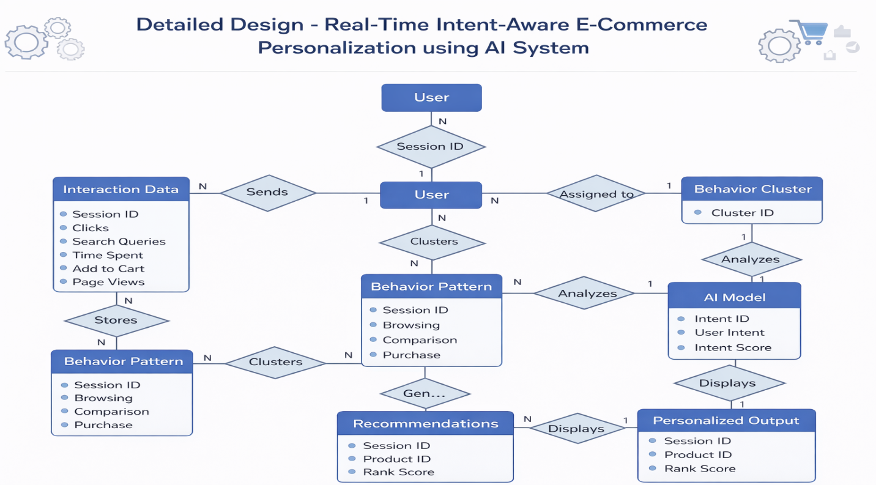
Fig:3.7 System Architecture
The system architecture defines how different components of the proposed system interact with each other to provide personalized recommendations.
The architecture follows a layered design consisting of the presentation layer, application layer, machine learning layer, and data storage layer.
The presentation layer includes the user interface through which users interact with the platform. This layer displays product information and recommendation results.
The application layer handles business logic and communication between system modules. It processes user requests and coordinates interactions between the database and machine learning modules.
The machine learning layer performs data analysis and intent detection tasks. It processes user behavior data and generates prediction results that guide the recommendation engine.
Finally, the data storage layer manages all system data including product details, user profiles, and behavioral interaction logs.

3.7.1 System Architecture Diagram
User
|
Frontend (React UI)
|
Backend API (Node.js / Express)
|
User Behavior Tracking Module
|
Intent Detection Model (Machine Learning)
|
Recommendation Engine
|
Database (Product + User Data)
Fig:3.7.1 System Architecture Diagram
The system architecture follows a modular design approach to ensure flexibility and scalability. Each module within the architecture performs a specific function while maintaining communication with other modules through well-defined interfaces.
The architecture begins with the user interface layer, where users interact with the e-commerce platform through web or mobile applications. This layer is responsible for presenting product information and collecting user interaction data.
The application layer acts as the central controller of the system. It manages user requests, processes data, and communicates with the machine learning components.
The machine learning layer performs advanced data analysis tasks such as intent detection, behavior pattern analysis, and recommendation generation. This layer uses trained models to analyze incoming data and produce prediction results.
The data storage layer stores all system-related information including product details, user profiles, interaction logs, and recommendation results.
This layered architecture ensures efficient communication between system components and supports the development of scalable recommendation systems.

3.7.2 User behavior Tracking Flowchart
Start
|
User Interaction
|
Capture Click/Search/View
|
Store Interaction Data
|
Send Data to ML Model
|
Analyze Behavior Pattern
|
Update Recommendation Model
|
End
Fig:3.7.2 User Behavior Tracking Flowchart
3.8 System Requirements Analysis:

System requirements analysis involves identifying the hardware and software resources required to develop and operate the proposed system. This process ensures that the system is capable of performing its intended functions efficiently.
The proposed system requires a computing environment capable of processing large amounts of user data and running machine learning algorithms. The software requirements include programming languages, machine learning frameworks, and database management systems used for system development.
The system must also support real-time data processing to analyze user interactions and generate recommendations instantly. Proper requirement analysis helps ensure that the system operates reliably and meets the objectives of the project.
Proper requirement analysis is essential for ensuring that the system performs efficiently under different operating conditions.
Hardware requirements include sufficient processing power, memory capacity, and storage space to handle large volumes of data generated by user interactions.
Software requirements include programming languages such as Python, JavaScript, and frameworks used for machine learning and web development.
The system must also support secure data communication protocols to protect user information and ensure reliable data transmission between system modules.
Additionally, the system must be capable of handling multiple simultaneous user requests without performance degradation.

3.9 Functional Requirements:

Functional requirements describe the specific features and operations that the system must perform. These requirements define how the system interacts with users and processes data.
The system must be capable of tracking user behavior such as browsing history, clicks, search queries, and time spent on product pages. It should analyze this data using machine learning techniques to detect the user’s intent.
The system must generate personalized product recommendations based on the detected intent and display them to users through the user interface. It should also allow administrators to manage product data and monitor system performance.
These functional requirements ensure that the system operates effectively and delivers personalized recommendations to users.
The system must support user authentication and session management to ensure secure access to the platform.
Another functional requirement is product search functionality, which allows users to search for products using keywords or filters such as price range and product category.
The system must also maintain a history of user interactions so that machine learning models can analyze behavioral patterns and generate recommendations.
Administrative functionalities should include product management, data monitoring, and system performance analysis.
These functional capabilities ensure that the system operates smoothly and meets the needs of both users and administrators.

3.10 Non-Functional Requirements:

Non-functional requirements describe the performance, reliability, and quality attributes of the system. These requirements ensure that the system operates efficiently and provides a satisfactory user experience.
The system must provide fast response times so that recommendations are generated in real time without delays. It should maintain high reliability and accuracy in detecting user intent and generating recommendations.
Security is another important requirement, as the system must protect user data and ensure privacy. The system should also be scalable so that it can handle increasing numbers of users and large volumes of product data.
Additionally, the system should provide a user-friendly interface and ensure compatibility with different devices and platforms.
In addition to functional requirements, the system must satisfy several quality attributes that influence overall system performance.
Performance is a critical requirement for recommendation systems because users expect instant responses when browsing products. The system must generate recommendations quickly without affecting page loading times.
Reliability ensures that the system continues to function correctly even when large numbers of users access the platform simultaneously.
Security is another essential requirement. The system must protect sensitive user data such as personal information and browsing history.
Scalability ensures that the system can handle increasing workloads as the platform grows. The architecture must support expansion without requiring major redesign.
Finally, usability is an important factor. The user interface must be intuitive and easy to navigate so that users can interact with the platform without difficulty.

CHAPTER 4
LANGUAGE SPECIFICATION

Language specification refers to the description of the programming languages, frameworks, tools, and technologies used in the development of a software system. It explains why particular technologies are selected and how they contribute to building the proposed system. This section helps readers understand the technical environment in which the system is designed and implemented.
In software development, different components of a system require different technologies. For example, programming languages are used to write the logic of the application, web technologies are used to design the user interface, and database systems are used to store and manage data. Language specification describes these technologies in detail and explains their role in the system.
In the proposed Real-Time Intent-Aware E-Commerce Personalization System, multiple technologies are used to implement different parts of the system. Python is used for implementing machine learning algorithms and analyzing user behavior. Web development technologies such as HTML, CSS, and JavaScript are used to design the user interface and enable user interaction with the system. Backend technologies manage server-side operations and connect the application with the database.
Language specification also explains the development tools and frameworks used in the project. These tools support system development, debugging, testing, and deployment. By clearly specifying the technologies used, this section provides a technical overview of the system and helps developers understand how the system is implemented.
Another important aspect of language specification is describing how these technologies integrate with each other. For example, the user interface communicates with the backend server, which processes user requests and interacts with the machine learning models. The database stores product information and user interaction data that are required for generating recommendations.
Overall, the language specification section provides a detailed description of the technologies used in the system and their roles in implementing the proposed solution. It helps ensure that the system is developed using appropriate tools and technologies that support efficiency, scalability, and performance.

4.1 Overview of Programming Languages and Technologies Used:

The development of the proposed Real-Time Intent-Aware E-Commerce Personalization System using Artificial Intelligence requires the integration of multiple programming languages and technologies. These technologies work together to build an efficient, scalable, and intelligent system capable of analyzing user behavior and providing personalized product recommendations.
The system mainly uses Python for implementing machine learning algorithms and data analysis tasks. Python is widely used in artificial intelligence and data science because of its simplicity, flexibility, and availability of powerful libraries. In addition to Python, web development technologies such as HTML, CSS, and JavaScript are used to design the user interface and enable user interaction with the e-commerce platform.
Frontend frameworks are used to improve the visual appearance and responsiveness of the user interface. Backend technologies are used to handle server-side operations such as processing user requests, running recommendation algorithms, and managing database interactions.
The system also uses a database management system to store product information, user profiles, browsing history, and recommendation results. Development tools and software platforms are used to design, test, and deploy the system effectively. By integrating artificial intelligence techniques with web technologies, the proposed system is able to provide real-time personalized recommendations to users.
In modern intelligent e-commerce platforms, the integration of multiple technologies is essential for building a system that can handle large amounts of data and provide real-time personalized services. The proposed system combines machine learning technologies, web development frameworks, backend services, and database systems to create a complete e-commerce recommendation platform.
Programming languages play a major role in implementing different layers of the system. For example, Python is widely used for implementing machine learning algorithms, while JavaScript and related frameworks are used for developing dynamic user interfaces. Each technology in the system is selected based on its efficiency, scalability, and compatibility with other components.
The system architecture follows a multi-layer structure consisting of the frontend layer, backend layer, machine learning layer, and database layer. The frontend layer is responsible for interacting with users and displaying product recommendations. The backend layer processes requests and communicates with machine learning modules. The machine learning layer performs data analysis and prediction tasks, while the database layer manages storage and retrieval of large volumes of user interaction data.

4.2 Python Programming Language for Machine Learning Implementation:

Python is one of the most widely used programming languages for artificial intelligence and machine learning applications. It is an open-source, high-level programming language that provides a simple syntax and powerful libraries for data analysis and machine learning.
In this project, Python is used to implement the recommendation algorithms and user behavior analysis modules. Python libraries such as NumPy, Pandas, Scikit-learn, and TensorFlow provide efficient tools for handling large datasets, performing data preprocessing, and building machine learning models.
Python allows developers to write code quickly and efficiently while maintaining readability and simplicity. Its extensive community support and large collection of libraries make it an ideal choice for developing intelligent systems. Python also integrates easily with web technologies and databases, enabling smooth communication between different components of the system.
By using Python for machine learning implementation, the system can analyze user behavior patterns, detect user intent, and generate personalized product recommendations effectively.
Python has become the dominant programming language in the field of artificial intelligence due to its simplicity and powerful ecosystem of libraries. The language supports various frameworks that simplify complex data processing tasks and allow developers to build machine learning models efficiently.
In the proposed system, Python is primarily used for data preprocessing, feature extraction, model training, and prediction tasks. Data collected from user interactions must first be cleaned and structured before it can be used for machine learning. Python libraries such as Pandas help organize large datasets into structured formats that are easier to analyze.
Another important advantage of Python is its support for scientific computing libraries such as NumPy, which provide efficient operations for numerical data. These libraries allow the system to process large datasets containing thousands of user interactions quickly.
Machine learning frameworks such as Scikit-learn and TensorFlow help build classification models that can detect user intent. These models learn patterns from historical user data and apply this knowledge to predict the behavior of new users. Python also provides visualization tools that help developers analyze system performance and improve recommendation accuracy.
Because of these capabilities, Python plays a crucial role in enabling the artificial intelligence functionality of the proposed system.

4.3 Intent Detection using Machine Learning:

Intent detection is an important component of the proposed system. It refers to the process of identifying the purpose behind a user’s actions while interacting with an e-commerce platform. Understanding user intent helps the system provide more accurate and relevant product recommendations.
Machine learning techniques are used to analyze user interactions such as search queries, clicks, browsing patterns, and time spent on product pages. These behavioral signals are used as input data for machine learning models.
The system processes this data using algorithms that identify patterns and relationships in user behavior. Based on this analysis, the system can determine whether the user is browsing products casually, comparing items, or preparing to make a purchase.
Once the user’s intent is detected, the recommendation engine generates product suggestions that match the user’s current needs. This real-time intent detection improves the accuracy and effectiveness of the recommendation system.
Intent detection allows the system to understand what a user is trying to achieve while interacting with an e-commerce platform. Traditional recommendation systems often rely only on past purchases or simple browsing history, which may not accurately reflect the user's current needs. Intent detection improves this process by analyzing real-time user behavior.
Machine learning algorithms examine different behavioral signals such as page views, click patterns, search activity, and time spent on product pages. These signals are converted into numerical features that can be processed by machine learning models. Feature engineering techniques are used to identify the most important factors influencing user decisions.
Classification algorithms can then be used to categorize user intent into predefined categories. For example:
- Browsing intent indicates casual exploration of products.
- Comparison intent indicates that the user is evaluating multiple products.
- Purchase intent indicates that the user is ready to buy a product.
By accurately detecting user intent, the system can provide recommendations that match the user's current stage in the purchasing process. This approach significantly improves the relevance of recommendations and increases the probability of successful product purchases.

4.4 Web Development Technologies (HTML, CSS, JavaScript):

Web development technologies play an essential role in designing the user interface of the e-commerce platform. The system uses HTML, CSS, and JavaScript to create interactive and user-friendly web pages.
HTML (HyperText Markup Language) is used to structure the content of web pages. It defines elements such as headings, text, images, buttons, and product listings. HTML provides the basic framework for displaying information on the website.
CSS (Cascading Style Sheets) is used to control the appearance and layout of web pages. It helps design visually appealing interfaces by defining colors, fonts, spacing, and layout styles. CSS also enables responsive design so that the website works properly on different devices.
JavaScript is used to add interactivity and dynamic behavior to web pages. It allows users to perform actions such as searching for products, filtering items, and viewing recommendations without reloading the entire page.
Together, these technologies create an engaging and interactive user experience for online shopping.
Web technologies form the foundation of the user interface in modern online platforms. HTML, CSS, and JavaScript work together to create interactive and responsive web applications that allow users to easily browse products and interact with the system.
HTML provides the structural elements of the web page. It defines the layout of product listings, images, navigation menus, and search components. Semantic HTML elements also improve accessibility and search engine optimization.
CSS is responsible for enhancing the visual design of the website. By applying styles such as colors, fonts, and layout structures, CSS ensures that the platform maintains a consistent and attractive appearance. Advanced CSS techniques such as flexbox and grid layouts enable responsive designs that adjust automatically to different screen sizes.
JavaScript is used to implement client-side logic and dynamic functionality. For example, JavaScript enables features such as product filtering, real-time search suggestions, and dynamic loading of recommended products. This allows the website to provide a smooth and interactive shopping experience without frequent page reloads.

4.5 Frontend Framework for User Interface Development:

Frontend frameworks are used to simplify the process of developing user interfaces and improve the performance of web applications. These frameworks provide pre-designed components and structured development approaches that make it easier to build complex interfaces.
In the proposed system, a frontend framework is used to develop the product browsing interface, recommendation display sections, and user interaction components. These frameworks help create responsive and visually attractive web pages that adapt to different screen sizes and devices.
Frontend frameworks also improve the maintainability of the code by organizing it into reusable components. This reduces development time and ensures consistency in the user interface design.
By using a frontend framework, the system can provide a smooth and interactive shopping experience while efficiently displaying personalized product recommendations to users.
Frontend frameworks play an important role in building modern web applications efficiently. Instead of writing large amounts of repetitive code, developers can use frameworks that provide reusable components and structured development patterns.
In the proposed system, the frontend framework helps manage various user interface components such as product listings, recommendation sections, rating displays, and comparison panels. These components interact with backend services through API calls to retrieve product data and recommendation results.
Component-based architecture is a key feature of modern frontend frameworks. Each part of the interface is developed as an independent component that can be reused in multiple sections of the application. This approach improves code organization and simplifies system maintenance.
Frontend frameworks also support state management techniques that help maintain consistency between different parts of the application. For example, when a user interacts with a product page, the system can update recommendation sections dynamically without refreshing the entire page.
Frontend frameworks simplify UI development by providing reusable components and structured development approaches. They help build responsive, visually appealing web pages that work across devices. In this system, frameworks manage product listings, recommendation sections, and interactive components efficiently. Component-based architecture ensures maintainable and organized code. Frameworks also support dynamic updates and state management, allowing smooth interaction without full page reloads.

4.6 Backend Development for Recommendation System:

The backend of the system is responsible for handling server-side operations and processing user requests. It acts as the bridge between the user interface and the machine learning models used for recommendation generation.
The backend processes user inputs such as search queries and browsing activities. It communicates with the machine learning module to analyze user behavior and detect user intent. Based on this analysis, the recommendation engine generates personalized product suggestions.
The backend also manages data storage and retrieval operations through the database system. It ensures that product information, user data, and recommendation results are stored and accessed efficiently.
Efficient backend development is essential for ensuring fast system performance and smooth communication between different system components.
The backend infrastructure provides the computational logic required to support the recommendation system. It receives user requests from the frontend interface and processes them through various system modules.
Backend services are responsible for executing recommendation algorithms, managing user sessions, and communicating with the database. When a user interacts with the platform, the backend collects this interaction data and forwards it to the machine learning module for analysis.
The backend also exposes APIs that allow the frontend interface to request product data, recommendation results, and user profile information. These APIs follow standardized communication protocols to ensure efficient data exchange.
Efficient backend architecture ensures that the system can handle multiple simultaneous user requests while maintaining fast response times.

4.7 Database Management System for Data Storage:

A database management system (DBMS) is used to store and manage the data required by the proposed system. The database contains important information such as product details, user profiles, browsing history, purchase records, and recommendation results.
The DBMS ensures that data is stored in a structured and organized manner. It provides efficient methods for inserting, updating, and retrieving data. The database also supports query operations that allow the system to analyze user behavior and generate recommendations.
Using a database system improves data consistency, security, and scalability. It allows the system to handle large volumes of user interaction data and product information effectively.
The database plays a crucial role in supporting the recommendation engine and enabling real-time personalization.
The database management system serves as the central storage repository for all system data. It maintains structured records of products, user profiles, browsing activity, and recommendation outputs.
A well-designed database schema ensures that data relationships are maintained properly. For example, product tables may store information such as product names, categories, prices, and ratings, while user tables store details about user preferences and browsing history.
The database also supports analytical operations that help the system understand user behavior patterns. By analyzing historical interaction data, the machine learning model can learn how users typically navigate the platform and identify trends in purchasing behavior.
Scalability is another important factor in database design. As the number of users grows, the system must be able to handle increasing volumes of data without affecting performance.
The backend handles server-side operations and processes user requests, connecting the frontend to machine learning modules. It analyzes user behavior, detects intent, and generates personalized product recommendations. The backend also manages data storage, retrieval, and session handling to ensure smooth system performance. APIs enable communication between frontend and backend for real-time updates. Efficient backend architecture ensures fast responses and reliable interactions under multiple user requests.

4.8 Development Tools and Software Requirements:

Several development tools and software platforms are used during the implementation of the proposed system. These tools help developers write, test, and deploy the application efficiently.
Integrated Development Environments (IDEs) such as Visual Studio Code or PyCharm are used to write and manage program code. These tools provide features such as syntax highlighting, debugging support, and code management capabilities.
Version control systems may also be used to track changes in the project and manage collaborative development. Testing tools are used to verify that the system functions correctly and performs as expected.
By using appropriate development tools, developers can ensure efficient system development and maintain high-quality software standards.
Software development requires various tools that assist programmers in writing and maintaining code efficiently. Integrated Development Environments (IDEs) provide features such as code completion, debugging support, and project management capabilities.
Version control systems such as Git help developers track changes in the project and collaborate effectively with other team members. These systems maintain a complete history of modifications and allow developers to revert to previous versions if necessary.
Testing frameworks are also used to ensure that the system performs as expected under different conditions. Developers perform unit testing, integration testing, and system testing to verify the functionality of different system modules.
These development tools improve productivity and ensure that the final software product is reliable and maintainable.
A database management system (DBMS) stores and organizes product details, user profiles, browsing history, and recommendation results. It provides efficient methods for data insertion, retrieval, and updates while maintaining consistency and security. The database supports analytical operations to help the recommendation engine personalize content in real time. Proper schema design ensures relationships between data are maintained. Scalability allows the system to handle growing user volumes without affecting performance.

4.9 Integration of AI with E-Commerce Platform:

Artificial intelligence plays a central role in the proposed e-commerce personalization system. AI techniques are used to analyze user behavior data and generate personalized product recommendations.
The integration of AI with the e-commerce platform involves connecting the machine learning models with the user interface and backend systems. When a user interacts with the platform, their actions are recorded and analyzed by the AI module.
The AI model processes this data to identify patterns and detect user intent. Based on this analysis, the recommendation engine generates personalized product suggestions and sends them to the user interface.
This integration allows the system to deliver intelligent recommendations that improve the shopping experience and increase customer engagement.
Integrating artificial intelligence into an e-commerce platform enables the system to transform raw user interaction data into valuable insights. AI algorithms analyze complex behavioral patterns that may not be easily detected using traditional programming approaches.
The AI module processes large datasets containing user browsing history, search queries, and purchase records. By analyzing these datasets, the system learns relationships between products and identifies user preferences.
Once the machine learning model is trained, it can predict user interests and generate product recommendations dynamically. The integration between AI modules and web application components allows these recommendations to be displayed instantly on the user interface.
This intelligent integration enhances the personalization capabilities of the platform and significantly improves the overall user experience.

4.10 System Workflow:

The system workflow describes the sequence of operations performed by the proposed system to generate personalized product recommendations.
First, the user accesses the e-commerce platform and begins browsing products. The system records user interactions such as clicks, searches, and time spent on product pages.
Next, the user behavior tracking module collects this data and sends it to the machine learning module for analysis. The intent detection module processes the data and identifies the user’s current intent.
Based on the detected intent, the recommendation engine selects relevant products from the database and generates personalized suggestions. These recommendations are then displayed to the user through the user interface.
The system continuously updates its analysis as the user interacts with the platform, ensuring that recommendations remain relevant throughout the browsing session.
The System Workflow describes the step-by-step process through which the proposed Real-Time Intent-Aware E-Commerce Personalization system operates. The workflow explains how user interactions are captured, processed, and used to generate personalized product recommendations using machine learning techniques.
The system begins when a user visits the e-commerce platform and interacts with different product pages. These interactions include activities such as product views, searches, comparisons, and adding products to the shopping cart. All these user activities are continuously monitored by the User Behavior Tracking Module.
The collected behavioral data is then processed and stored in the database. This data contains valuable information about user interests and preferences. The stored data is used as input for the Machine Learning based Intent Detection Model, which analyzes user actions to determine the user's shopping intent.
The machine learning model processes features such as:
- Number of product views
- Number of product comparisons
- Cart additions
- Time spent on product pages
- Search queries performed by the user
Based on these behavioral features, the model predicts the user’s intent. The predicted intent is classified into three major categories:
- Browsing – User is casually exploring products
- Comparing – User is comparing multiple products before making a decision
- Buying – User is ready to purchase a product
After detecting the user intent, the system activates the Recommendation Engine. The recommendation engine uses multiple algorithms such as similarity matching, popularity scoring, and intent-based filtering to generate relevant product suggestions.
These recommended products are then sent to the Frontend User Interface, where they are displayed to the user through the recommendation section of the website. This helps users quickly find products that match their interests and improves the overall shopping experience.
The entire workflow operates in real time, allowing the system to dynamically adjust recommendations as user behavior changes during a browsing session.

Start
|
User Opens Website
|
User Searches / Views Product
|
System Tracks User Behavior
|
Machine Learning Model Detects Intent
|
Recommendation Engine Generates Suggestions
|
Recommended Products Displayed
|
User Interaction Continues
|
End
Fig:4.10 System Workflow

CHAPTER 5
CONCLUSION & REFERENCES

5.1 Conclusion:
The rapid growth of online shopping platforms has significantly transformed the way people search for and purchase products. As e-commerce platforms continue to expand, the number of products available to users has increased exponentially, making it challenging for customers to locate items that match their specific needs and preferences. Personalized recommendation systems have therefore become a critical component of modern online shopping platforms, as they help enhance user experience, simplify product discovery, and increase engagement by suggesting relevant items based on individual behavior patterns.
In this project, a Real-Time Intent-Aware E-Commerce Personalization System leveraging artificial intelligence was proposed to improve recommendation efficiency and relevance. The system focuses on capturing and analyzing real-time user interactions, including search queries, click behavior, product views, and the time spent on different pages. By detecting user intent dynamically, the system can generate recommendations that are not only personalized but also contextually relevant to the user’s current shopping session. This represents a significant improvement over traditional recommendation approaches that rely primarily on historical data and static user profiles.
The architecture of the proposed system integrates multiple functional modules, including user behavior tracking, intent detection, recommendation generation, and database management. This modular design allows for efficient data processing, fast response times, and seamless communication between the frontend interface and backend services. Machine learning algorithms form the core of the recommendation engine, enabling the system to learn from user interactions continuously and adapt to changing preferences. The integration of web development technologies ensures that the platform remains interactive, responsive, and user-friendly across multiple devices.
An important advantage of the proposed system is its ability to enhance customer engagement and satisfaction. By providing personalized and timely recommendations, users can discover relevant products more quickly, reducing search effort and improving the overall shopping experience. The system’s real-time processing capability ensures that recommendations remain dynamic and accurate, even as user behavior evolves during a session. This not only increases the likelihood of successful purchases but also builds user trust and loyalty toward the platform.
The implementation of artificial intelligence in e-commerce platforms demonstrates the potential for creating intelligent, adaptive, and highly personalized shopping environments. Continuous analysis of user interactions allows the system to anticipate user needs, recommend complementary or alternative products, and provide a more intuitive and convenient shopping experience. Additionally, the system can handle large volumes of data efficiently, supporting scalability as the number of users and product offerings grows.
Looking forward, the system can be further enhanced by incorporating advanced techniques such as deep learning, natural language processing for better search query understanding, and sophisticated user profiling mechanisms. Such improvements could allow for even more accurate intent detection, context-aware recommendations, and personalized marketing strategies. The system could also integrate cross-platform user behavior analysis to provide consistent and seamless personalization across multiple devices and applications.
In conclusion, the proposed Real-Time Intent-Aware E-Commerce Personalization System demonstrates the effectiveness of combining artificial intelligence with real-time user behavior analysis to improve recommendation accuracy, enhance user experience, and increase customer engagement. By dynamically adapting to user intent, the system offers a more intelligent, responsive, and user-centric approach to online shopping. The findings of this project highlight the transformative potential of AI-driven personalization in e-commerce and provide a strong foundation for future research and development in this field.

5.2 References:

- Ricci, F., Rokach, L., & Shapira, B. (2020).“Recommender Systems: Techniques, Applications, and Challenges .” Springer International Publishing.This work provides a comprehensive overview of recommendation systems including collaborative filtering, content-based filtering, and hybrid recommendation approaches used in modern e-commerce platforms.

- Zhang, S., Yao, L., Sun, A., & Tay, Y. (2021).“Deep Learning Based Recommender Systems: A Survey and New Perspectives.”ACM Computing Surveys, 52(1), 1–38. This paper discusses various deep learning models used in recommendation systems and explains how neural networks improve personalization accuracy.

- Bobadilla, J., Ortega, F., Hernando, A., & Gutiérrez, A. (2020).“Recommender Systems Survey.” IEEE Transactions on Knowledge and Data Engineering.This research provides an overview of collaborative filtering techniques and their applications in personalized product recommendation systems.

- Koren, Y., Bell, R., & Volinsky, C. (2020). “Matrix Factorization Techniques for Recommender Systems.” IEEE Computer Journal.This study explains matrix factorization algorithms widely used for generating personalized recommendations in online platforms.

- Chen, L., Chen, G., & Wang, F. (2021). “Recommender Systems Based on User Reviews: The State of the Art.” User Modeling and User-Adapted Interaction Journal.The research focuses on analyzing user reviews and feedback to improve recommendation quality in e-commerce systems.

- He, X., Liao, L., Zhang, H., Nie, L., Hu, X., & Chua, T. (2022). “Neural Collaborative Filtering.” Proceedings of the World Wide Web Conference. This paper proposes neural network-based collaborative filtering techniques to improve recommendation accuracy.

- Liu, Q., Wu, S., Wang, D., & Li, Z. (2023). “Context-Aware Sequential Recommendation.” IEEE International Conference on Data Mining.This research introduces context-aware recommendation techniques that analyze user behavior sequences for better product suggestions.

- Zhao, L., & Liu, X. (2024). “Intent Detection in E-Commerce Using Machine Learning Algorithms.” Journal of Artificial Intelligence Research. This study explores machine learning models that detect user shopping intent from browsing patterns and interaction data.

- Gupta, S., & Patel, A. (2023). “Artificial Intelligence Based Personalized Recommendation Systems in E-Commerce Platforms.” International Journal of Computer Science and Information Technology.The research explains how AI algorithms improve product personalization in online shopping platforms.

APPENDIX:
6.1 Coding
The coding section presents the important implementation parts of the proposed system. The system is developed using modern web technologies and machine learning techniques to build an intelligent e-commerce recommendation platform. The coding implementation is divided into different modules such as user interface development, recommendation engine, user behavior tracking module, machine learning model, and backend services.
The following sections present the major source code components used in the system.

6.2 USER INTERFACE SOURCE CODE
6.2.1 Code for Product Page
import React from "react";
import RatingStars from "./RatingStars";
import RecommendationSection from "./RecommendationSection";
import RecentlyViewedProducts from "./RecentlyViewedProducts";
const ProductPage = ({ product }) => {
return (
<div className="product-page">
<h1>{product.title}</h1>
<img src={product.image} alt={product.title} width="250"/>
<p>{product.description}</p>
<h3>Price: ${product.price}</h3>
<RatingStars rating={product.rating} />
<RecommendationSection productId={product.id} />
<RecentlyViewedProducts />
</div>
);
};
export default ProductPage;

6.2.2 Code for Product Card
import React from "react";
import RatingStars from "./RatingStars";
const ProductCard = ({ product }) => {
return (
<div className="product-card">
<img src={product.image} alt={product.title} width="150"/>
<h4>{product.title}</h4>
<p>${product.price}</p>
<RatingStars rating={product.rating} />
</div>
);
};
export default ProductCard;

6.2.3 Code for Recommendation Section
import React, { useEffect, useState } from "react";
import ProductCard from "./ProductCard";
const RecommendationSection = ({ productId }) => {
const [recommendations, setRecommendations] = useState([]);
useEffect(() => {
fetch(`/api/recommend/${productId}`)
.then((res) => res.json())
.then((data) => setRecommendations(data));
}, [productId]);
return (
<div>
<h2>Recommended Products</h2>
<div className="recommendation-list">
{recommendations.map((item) => (
<ProductCard key={item.id} product={item} />
))}
</div>
</div>
);
};
export default RecommendationSection;

6.2.4 Code for Compare Products
import React from "react";
const CompareProducts = ({ products }) => {
return (
<div>
<h2>Compare Products</h2>
<table border="1">
<thead>
<tr>
<th>Product Name</th>
<th>Price</th>
<th>Rating</th>
</tr>
</thead>
<tbody>
{products.map((p) => (
<tr key={p.id}>
<td>{p.title}</td>
<td>${p.price}</td>
<td>{p.rating}</td>
</tr>
))}
</tbody>
</table>
</div>
);
};
export default CompareProducts;

6.2.5 Coding for Rating Stars
import React from "react";
const RatingStars = ({ rating }) => {
const stars = [];
for (let i = 1; i <= 5; i++) {
if (i <= rating) {
stars.push(<span key={i}>⭐</span>);
} else {
stars.push(<span key={i}>☆</span>);
}
}
return <div>{stars}</div>;
};
export default RatingStars;

6.2.6 Coding for Recently Viewed Products
import React, { useEffect, useState } from "react";
import ProductCard from "./ProductCard";
const RecentlyViewedProducts = () => {
const [products, setProducts] = useState([]);
useEffect(() => {
const viewed = JSON.parse(localStorage.getItem("recentProducts")) || [];
setProducts(viewed);
}, []);
return (
<div>
<h2>Recently Viewed Products</h2>
<div className="recent-products">
{products.map((item) => (
<ProductCard key={item.id} product={item} />
))}
</div>
</div>
);
};
export default RecentlyViewedProducts;

6.3 Recommendation System Module source code
6.3.1 Code for Recommendation Engine
Generates recommended products based on user preferred category and product ratings.
export interface Product {
id: string;
name: string;
category: string;
price: number;
rating: number;
}
export function recommendationEngine(
userCategory: string,
products: Product[]
): Product[] {
// Filter products based on user interested category
const filteredProducts = products.filter(
(product) => product.category === userCategory
);
// Sort products by rating
const sortedProducts = filteredProducts.sort(
(a, b) => b.rating - a.rating
);
// Return top 5 products
return sortedProducts.slice(0, 5);
}

6.3.2 Code for Similar Products
Finds products that belong to the same category as the selected product.

import { Product } from "./recommendationEngine";
export function findSimilarProducts(
product: Product,
products: Product[]
): Product[] {
const similar = products.filter(
(p) =>
p.category === product.category &&
p.id !== product.id
);
return similar.slice(0, 5);
}

6.3.3Code for Popularity Score
Calculates product popularity using views and purchases.
Formula used:
Popularity Score =
(views × 0.4) + (purchases × 0.6)

export interface ProductStats {
productId: string;
views: number;
purchases: number;
}
export function calculatePopularityScore(
stats: ProductStats
): number {
const viewWeight = 0.4;
const purchaseWeight = 0.6;
const score =
stats.views * viewWeight +
stats.purchases * purchaseWeight;
return score;
}
6.3.4 Code for Intent Recommendation
Provides recommendations based on user intent.

import { Product } from "./recommendationEngine";
export type IntentType =
| "BROWSING"
| "COMPARING"
| "BUYING";
export function intentRecommendation(
intent: IntentType,
products: Product[]
): Product[] {
if (intent === "BROWSING") {
return products.slice(0, 5);
}
if (intent === "COMPARING") {
return products
.sort((a, b) => b.rating - a.rating)
.slice(0, 5);
}
if (intent === "BUYING") {
return products
.sort((a, b) => a.price - b.price)
.slice(0, 5);
}
return [];
}

6.4 Behavior Tracking Module source code
6.4.1 Code for Behavior Tracker
export interface UserBehavior {
userId: string;
productId: string;
action: string;
timestamp: number;
}
export class BehaviorTracker {
private behaviors: UserBehavior[] = [];
trackBehavior(userId: string, productId: string, action: string) {
const behavior: UserBehavior = {
userId,
productId,
action,
timestamp: Date.now()
};
this.behaviors.push(behavior);
return behavior;
}
getUserBehavior(userId: string) {
return this.behaviors.filter(b => b.userId === userId);
}
}

6.4.2 Code for User Interaction Logger
export interface InteractionLog {
userId: string;
page: string;
action: string;
time: number;
}
export class UserInteractionLogger {
private logs: InteractionLog[] = [];
logInteraction(userId: string, page: string, action: string) {
const log: InteractionLog = {
userId,
page,
action,
time: Date.now()
};
this.logs.push(log);
console.log("User Interaction Logged:", log);
return log;
}
getLogs() {
return this.logs;
}
}
6.4.3 Code for Session Tracking
export interface UserSession {
sessionId: string;
userId: string;
startTime: number;
endTime?: number;
}
export class SessionTracking {
private sessions: UserSession[] = [];
startSession(userId: string) {
const session: UserSession = {
sessionId: Math.random().toString(36).substring(2),
userId,
startTime: Date.now()
};
this.sessions.push(session);
return session;
}
endSession(sessionId: string) {
const session = this.sessions.find(s => s.sessionId === sessionId);
if (session) {
session.endTime = Date.now();
}
return session;
}
getSessions() {
return this.sessions;
}
}

6.5 Code for Machine Learning Model
6.5.1 Code for Intent Model
export type IntentType =
| "BROWSING"
| "COMPARING"
| "BUYING";
export interface UserActivity {
views: number;
comparisons: number;
cartAdds: number;
}
export class IntentModel {
detectIntent(activity: UserActivity): IntentType {
if (activity.cartAdds > 0) {
return "BUYING";
}
if (activity.comparisons > 2) {
return "COMPARING";
}
return "BROWSING";
}
}

6.5.2 Code for Train Intent Model
import { IntentModel, UserActivity } from "./intentModel";
const trainingData: UserActivity[] = [
{ views: 5, comparisons: 0, cartAdds: 0 },
{ views: 8, comparisons: 3, cartAdds: 0 },
{ views: 10, comparisons: 2, cartAdds: 1 }
];
const model = new IntentModel();
export function trainIntentModel() {
console.log("Training Intent Detection Model...");
trainingData.forEach((data) => {
const intent = model.detectIntent(data);
console.log("Activity:", data, "Predicted Intent:", intent);
});
console.log("Training Completed");
}

6.5.3 Code for Predict Intent
import { IntentModel, UserActivity } from "./intentModel";
const model = new IntentModel();
export function predictIntent(activity: UserActivity) {
const intent = model.detectIntent(activity);
return {
activity,
predictedIntent: intent
};
}
6.6 Code for Backend / API files
6.6.1 Code for Product controller
import { Request, Response } from "express";
import { ProductService } from "../services/product.service";
const productService = new ProductService();
export class ProductController {
async getAllProducts(req: Request, res: Response) {
const products = await productService.getProducts();
res.json(products);
}
async getProductById(req: Request, res: Response) {
const id = req.params.id;
const product = await productService.getProductById(id);
if (!product) {
return res.status(404).json({ message: "Product not found" });
}
res.json(product);
}
}

6.6.2 Code for Recommendation controller
import { Request, Response } from "express";
import { RecommendationService } from "../services/recommendation.service";
const recommendationService = new RecommendationService();
export class RecommendationController {
async getRecommendations(req: Request, res: Response) {
const userId = req.params.userId;
const recommendations =
await recommendationService.generateRecommendations(userId);
res.json(recommendations);
}
}

6.6.3 Code for Product service
export interface Product {
id: string;
name: string;
category: string;
price: number;
rating: number;
}
export class ProductService {
private products: Product[] = [
{
id: "1",
name: "Wireless Headphones",
category: "Electronics",
price: 120,
rating: 4.5
},
{
id: "2",
name: "Smart Watch",
category: "Electronics",
price: 150,
rating: 4.4
},
{
id: "3",
name: "Running Shoes",
category: "Fashion",
price: 90,
rating: 4.3
}
];
async getProducts() {
return this.products;
}
async getProductById(id: string) {
return this.products.find(product => product.id === id);
}
}

6.7 Sample Dataset Used

The proposed Real-Time Intent-Aware E-Commerce Personalization System uses a dataset that contains product information, user interaction data, and recommendation related details. The dataset helps the system analyze user behavior and generate personalized product recommendations.
The following table shows a sample dataset used for training and testing the recommendation model.
The proposed recommendation system uses a sample dataset that contains information about user interactions with various products on the e-commerce platform. The dataset is used to train and evaluate the machine learning model responsible for detecting user intent and generating personalized recommendations.
The dataset mainly consists of user behavior records such as product views, search queries, clicks, and purchase actions. Each record represents a user interaction with a specific product at a particular time. These interaction logs help the system understand how users navigate the platform and what types of products attract their interest.
The dataset contains several important attributes including User ID, Product ID, Product Category, Search Query, Clicked Product, Time Spent on Product Page, Purchase Status, and Timestamp. These attributes allow the machine learning model to analyze user behavior patterns and identify potential buying intentions.
The collected dataset is preprocessed before training the machine learning model. Data preprocessing includes tasks such as removing duplicate entries, handling missing values, and converting categorical data into numerical format suitable for machine learning algorithms.
After preprocessing, the dataset is divided into training and testing sets. The training dataset is used to train the machine learning model, while the testing dataset is used to evaluate the performance and accuracy of the recommendation system.
Using this dataset, the system learns how users interact with different products and predicts relevant product recommendations based on the detected user intent.

Table 6.7.1 Sample Product Dataset

Product_ID | Product_Name | Category | Price | Rating | Description
101 | Wireless Headphones | Electronics | 2999 | 4.5 | Noise cancelling Bluetooth headphones
102 | Smart Watch | Electronics | 4999 | 4.3 | Fitness tracking smartwatch
103 | Running Shoes | Fashion | 1999 | 4.2 | Lightweight sports running shoes
104 | Laptop Backpack | Accessories | 999 | 4.4 | Waterproof laptop bag
105 | Mobile Phone | Electronics | 15999 | 4.6 | Android smartphone with high performance
106 | T-Shirt | Fashion | 499 | 4.1 | Cotton casual t-shirt
107 | Gaming Mouse | Electronics | 1299 | 4.5 | High precision gaming mouse
108 | Bluetooth Speaker | Electronics | 1799 | 4.4 | Portable wireless speaker

Table 6.7.2 Sample User Behavior Dataset

User_ID | Product_ID | Clicks | Time_Spent (sec) | Purchase
U101 | 101 | 3 | 120 | Yes
U102 | 103 | 2 | 60 | No
U103 | 105 | 4 | 180 | Yes
U104 | 107 | 1 | 45 | No
U105 | 102 | 2 | 90 | Yes
U106 | 108 | 3 | 110 | No

Table 6.7.3 Sample Recommendation Output

User_ID | Recommended_Product | Recommendation_Score
U101 | Smart Watch | 0.92
U102 | Running Shoes | 0.88
U103 | Mobile Phone | 0.95
U104 | Gaming Mouse | 0.85

The sample dataset contains information related to products and user interactions within the e-commerce platform. The product dataset includes attributes such as product ID, product name, category, price, rating, and description. This information helps the recommendation system identify similarities between products.
The user behavior dataset records interactions between users and products. It includes data such as clicks, time spent on product pages, and purchase status. These behavioral indicators help the system analyze user interests and detect user intent.
The recommendation output dataset shows the results generated by the recommendation engine. Based on user interactions and machine learning analysis, the system generates personalized product suggestions along with recommendation scores.
This dataset structure supports the development and evaluation of the proposed real-time intent-aware recommendation system.

6.8 Implementation

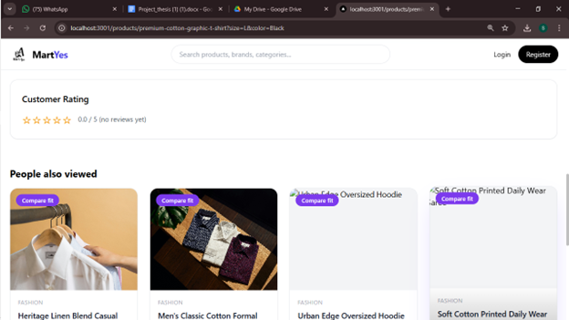
Fig:6.8.1 E-Commerce Platform Home Page Interface
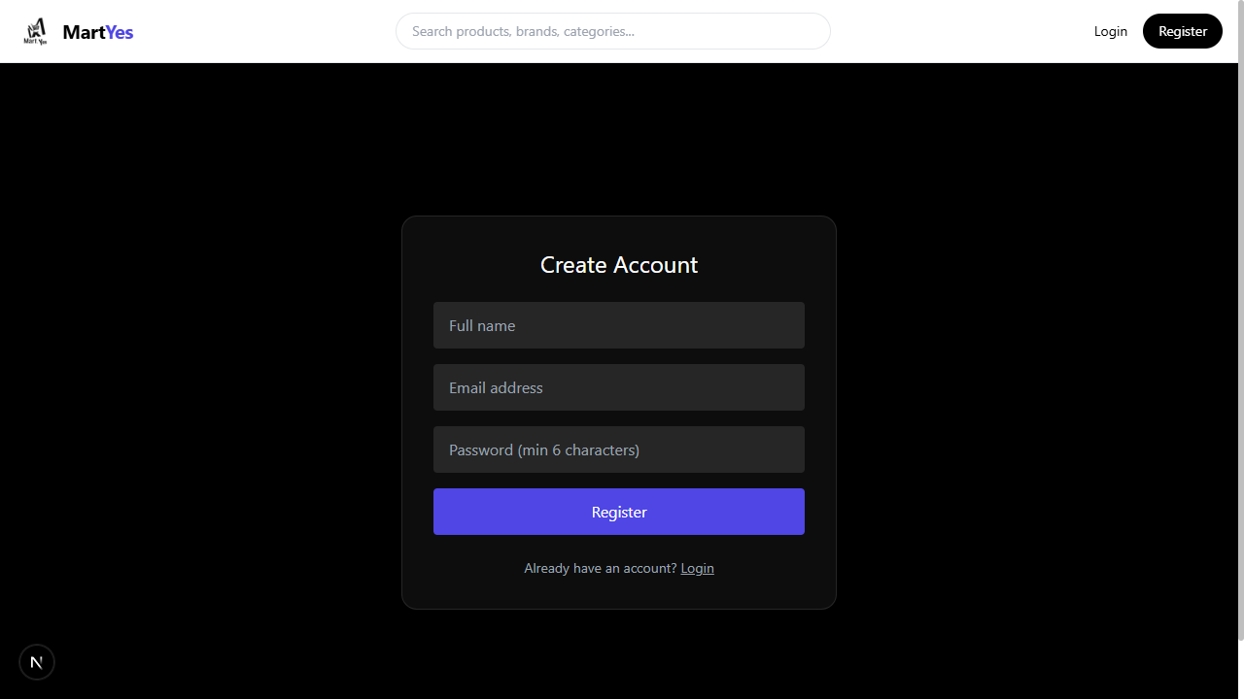
Fig:6.8.2 User Registration Interface

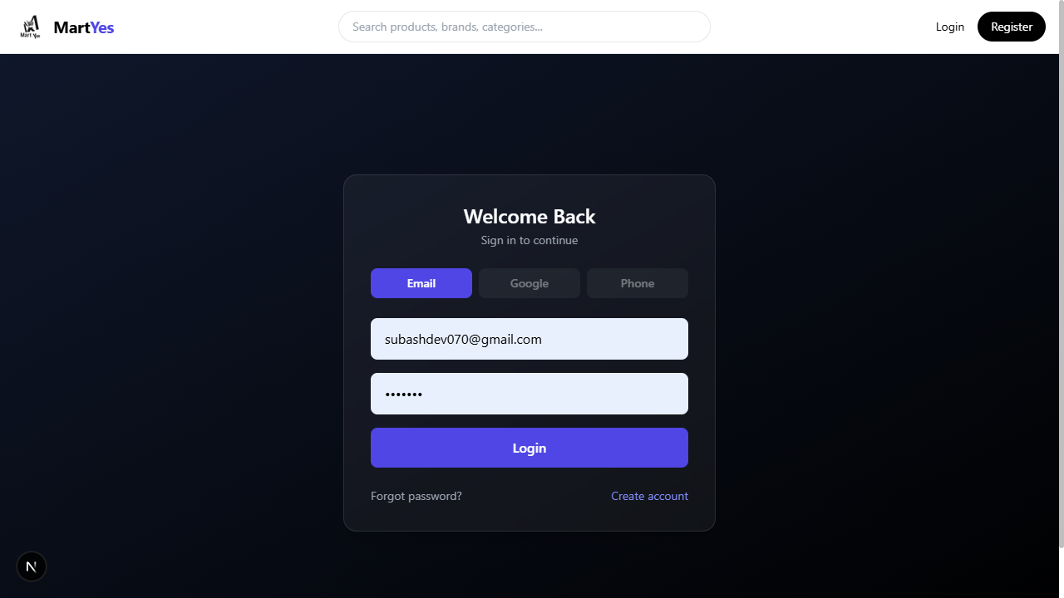
Fig:6.8.3 User Login Authentication Interface

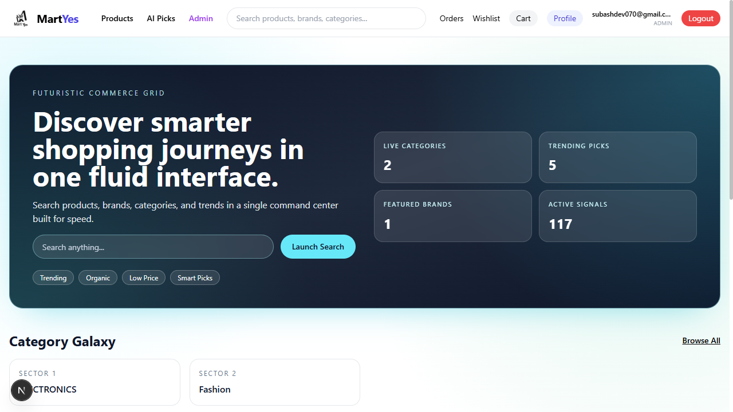
Fig:6.8.4 Product Search Interface

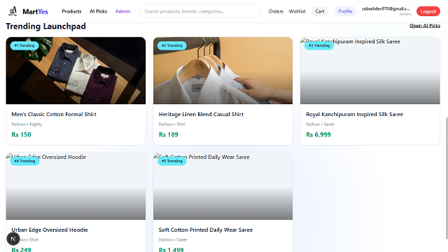
Fig:6.8.5 Trending and Newly Launched Products Interface

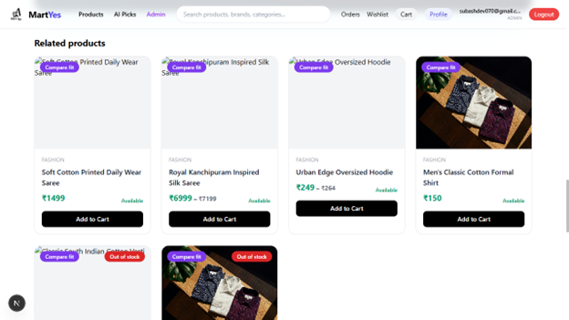
Fig:6.8.6Related Products Recommendation Interface

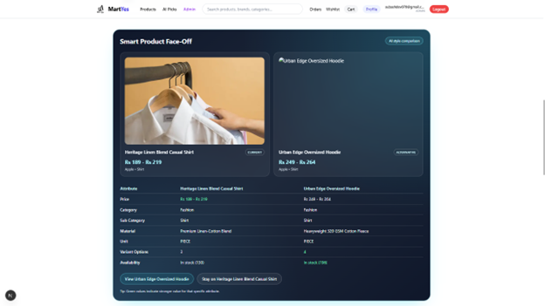
Fig:6.8.7 Smart Product Face-Off Comparison Interface
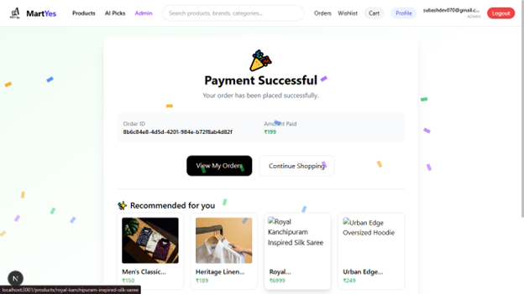
Fig: 6.8.8 Payment Successful Confirmation Page

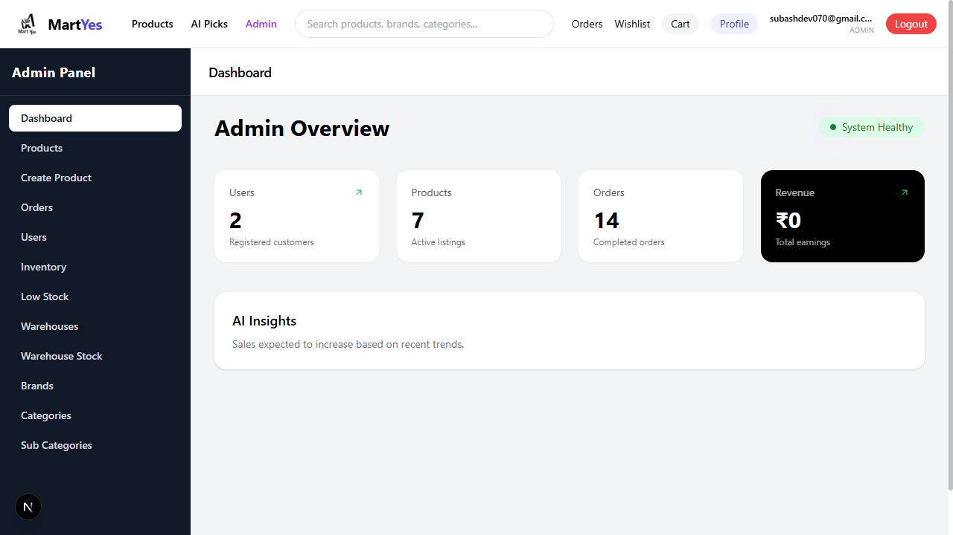
Fig:6.8.9 Admin Dashboard Overview Interface
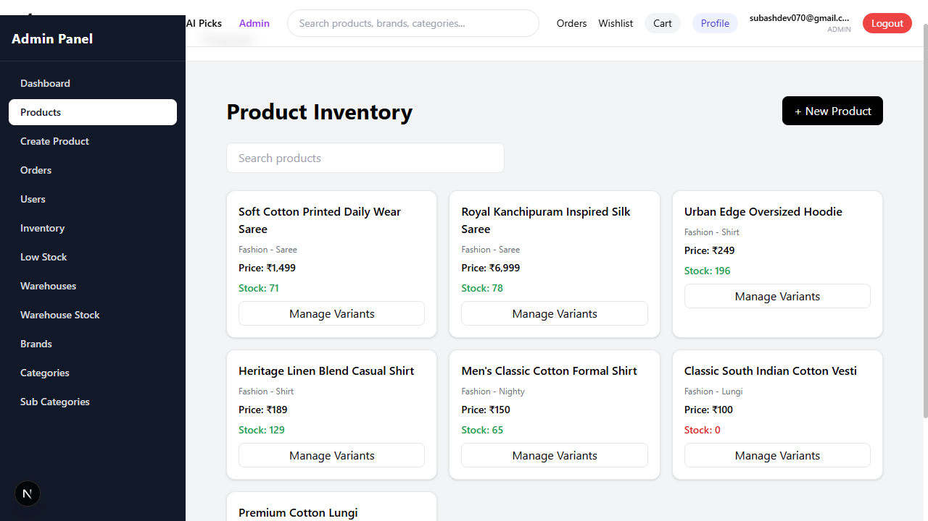
Fig:6.8.10 Product Inventory Management Interface

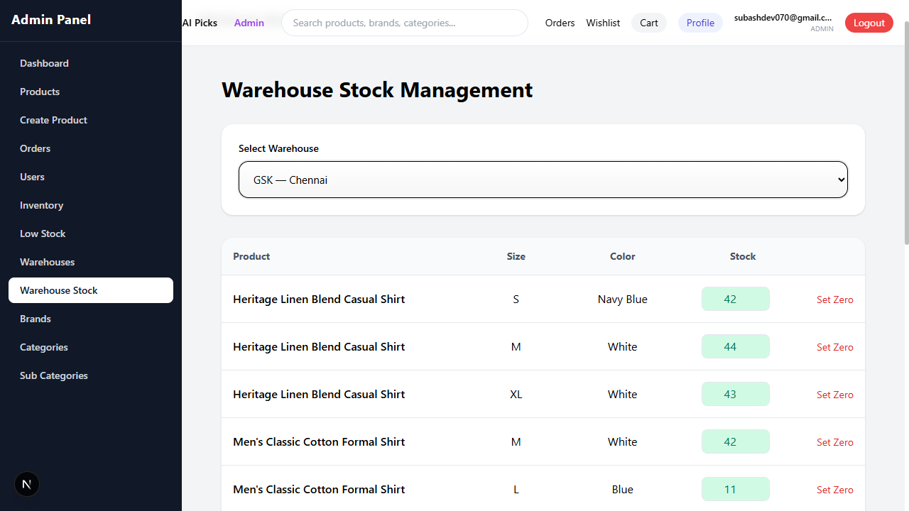
Fig:6.8.11 Warehouse Stock Management Interface
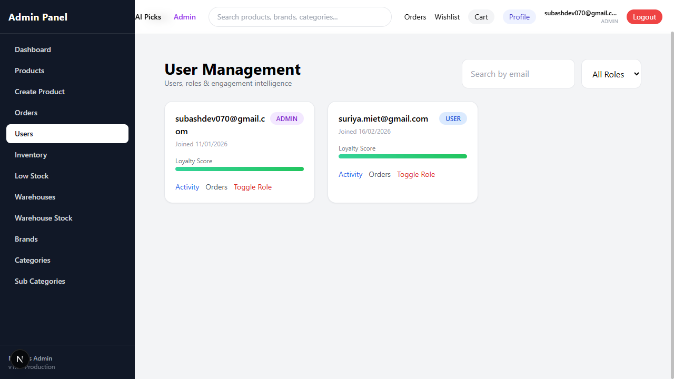
Fig:6.8.12 Admin Panel – User Management Interface

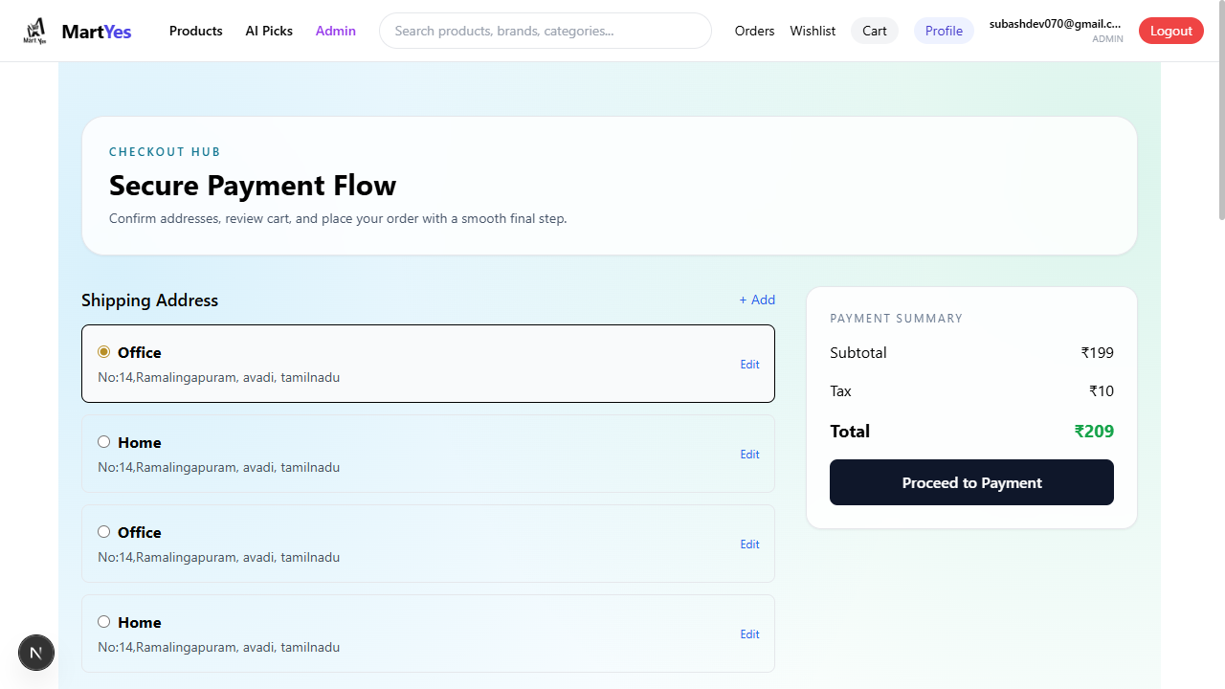
Fig:6.8.13 Secure Payment and Checkout Interface
7.CERTIFICATE

